Proposal for Sustainable Gardening Course

By Aoife Munn

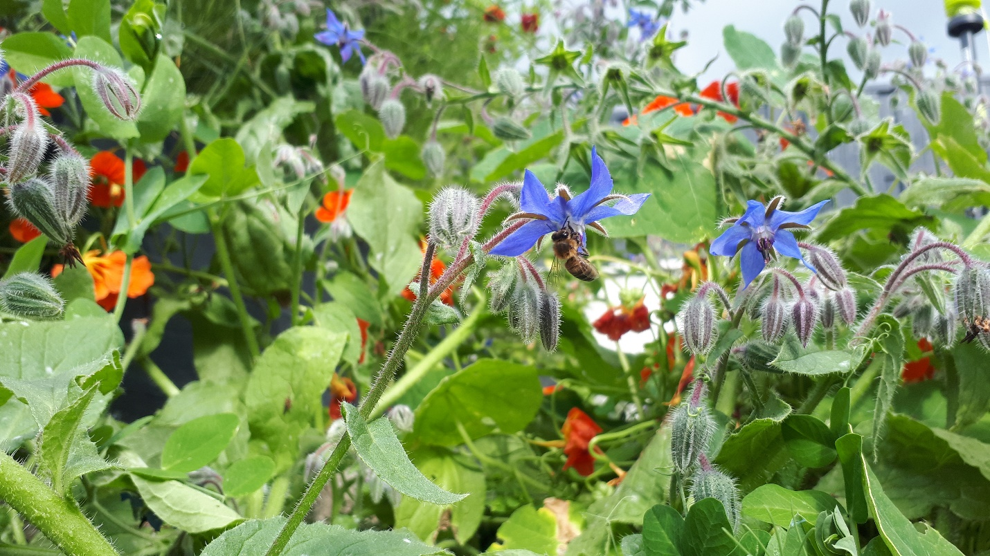

Contents

Introduction – This Course is based on practical workshops showing groups how to implement the ALL-IRELAND POLLINATOR PLAN 2

The Different Strands to the Course 2

Biodiversity 2

Sustainability 2

Inclusivity 2

Wellbeing 3

Format 3

Number of Participants 3

Topics Covered 3

Sustainable Gardening One Day Course Plan 3

1) Chemicals 3

2) Vegetable Growing 3

3) Wildflower, Rewilding & Pollinator Planting 4

4) Pond Building 4

5) Pruning 4

6) Cuttings 4

7) Composting 4

8) Bulb 4

9) Seed 4

10) Peat-Free Compost 4

The Venue 5

Pricing 5

Added Support 5

Conclusions 5

# Introduction – This Course is based on practical workshops showing groups how to implement the ALL-IRELAND POLLINATOR PLAN

This project has at its aim the enabling of community groups to effectively improve their area for wildlife, increase pride of place and reduce pollution. By teaching a practical class on how to take cuttings, how to identify what creatures live in your area and what plants most benefit wildlife to community leaders we can enable them to improve local areas with a limited budget.

This project has been run by Dun Laoghaire Rathdown, Dublin City, Fingal, Wicklow, Waterford, Wexford, Kilkenny, Galway, Westmeath and Meath County Councils as well as by several businesses, PPN’s and Tidy Towns groups. It has been run on site in parks and community gardens and more recently online. It has been covered on Nationwide three times, on the 6 O’Clock News, 9 O’Clock News and Ireland AM. It has also been talked about on Radio one twice on the Sean O’Rourke Show and on several other radio stations too.

The success of the project is due to its simplicity and interactive design. Participants learn why they should protect the environment, how to protect it and who to turn to for support in doing so. They network with other groups in the area to get more support and they enjoy the course.

This project offers great value for money and is tailored to the community in which it is held. The course can be done during one full day with follow up notes, email support and lot of opportunities for questions on any projects they have in mind. It is particularly good for people who are member of resident’s associations, Tidy Towns, Green Schools and anyone looking to move towards more sustainable living.

The course also helps Tidy Towns group recruit more members and upskill existing members. The importance of community participation is emphasized and attendees are encouraged to get involved locally in improving their area for biodiversity.

# The Different Strands to the Course

Biodiversity – The main aim of the course is to get everyone working together to improve biodiversity in their area through worthwhile and effective projects. Planting for pollinators, wildlife corridors, creating habitats and actions to help specific wildlife are all included.

Sustainability – We want a Sustainable community and this will lead to less litter, less waste, more reuse, more grow your own, more zero waste websites etc. The course looks at moving the whole community towards a zero waste circular economy community.

Inclusivity – A huge emphasis is placed on inclusivity. I had a community development officer work with me for a while to ensure we achieve inclusivity not just on the course but promote it and explain how the groups can bring that back to their community organizations and tidy towns groups. We explain how to gain more members for the tidy towns, how to find a role for everyone and how the best sustainable models are always inclusive.

Wellbeing – Gardening has so many health benefits for physical and mental health and here in Ireland we are particularly lucky to have a mild climate with a long growing season. We can garden in Ireland all year round. The most benefits from gardening come when it is done on a regular basis and so the course looks at activities to take you through the winter months as well. When we garden as a tidy towns or other community group, we increase our own sense of wellbeing. The World Health Organization’s (WHO) lists of factors that improve wellbeing includes: getting fresh air, exercising, a sense of belonging, social interactions, a feeling of self-worth and emotional stability. Almost all of these WHO factors that improve wellbeing are done during gardening and being part of a gardening group and I would argue although you don’t generally sleep in the garden it improves sleep as most physical exercise does. This course maximised the benefits for wellbeing by emphasizing the importance of inclusion, encouraging year-round gardening and making tasks more manageable.

# Format

Currently I am finding that people don’t want to sign up to longer term commitments and what works best is either to run the course as a one-day course on the weekend from 10 a to 4pm or if running it during the week over two days i.e. two Tuesdays in a row from 10am to 12.30. The course can be run during the week or on the weekend

# Number of Participants

We aim to have about 40 participants on the course. To have this we usually take around 55 names as there will always be no shows. The Eventbrite link is provided to the sponsor and when signing up, participants agree that all information supplied can be shared with Aoife Munn and ( xx Sponsor) for the purposes of administering and running the course. The link can be shared with specific groups as desired by the sponsor. The list of those who sign up can be shared with the sponsor and places awarded as desired.

# Topics Covered

## Sustainable Gardening One Day Course Plan

1. Chemicals – why we have to stop using them. No excuses
2. Vegetable Growing
   * Learn about crop rotation
   * Permanent crops
   * Preparing the soil
   * Sowing techniques and spacing
   * Dealing with pests organically – break in to groups and discuss
   * Hands-on exercise for all participants as they prepare the soil and learn how to dig without putting their back out!

COFFEE BREAK

1. Wildflower, Rewilding & Pollinator Planting

* What’s the difference and which should we do where? And why?
* Learn about how assessing an area for projects
* The benefits of different areas for pollinators
* Watering correctly
* Hands on exercise: How to plant your pollinator plants correctly at the right depths

1. Pond Building – Demonstration on how to put in a mini pond to best benefit wildlife

LUNCH

1. Pruning
   * Learn when and how to prune young trees to avoid disease
   * Improve air circulation
   * Reduce the risk of damage to the tree as it ages
   * Improve fruiting
2. Cuttings
   * Seasonal cuttings
   * Division of plants
   * Aftercare
3. Composting
   * Learn about the 5 ingredients and how to combine them for the best compost
   * Know what not to put in the compost bin
   * Discover the different types of compost bin and how they all work
4. Bulb Planting
   * Not all bulbs are good for biodiversity discover which ones will best support wildlife in your area and how to plant them.
5. Seed Collection
   * Learn how to collect seeds
   * How to store them

## Peat-Free Compost

* + Learn how to use peat free compost
  + How it differs from multipurpose
  + Make your own biodegradable pot and sow seeds to take home

# The Venue

The venue is supplied by the whoever is sponsoring the course. This can be run in lots of different locations and has been run at community gardens, school gardens, parks and soccer grounds. What is required is a piece of ground that people can dig in. This must be previously dug ground as there will be no time to remove the grass etc before the class begins. The bed should be about 4msq if possible. You should be easily able to plant a plant into the ground.

Indoor space just needs to be big enough to hold 40 people, seating of any type would be great and toilets.

# Pricing

The cost for running the course for 35 people (50 names are taken as there will be no shows) over a weekend or one day workshop or online over 5 weeks is €2300 Plus VAT 23%. (Total including VAT €2829)

# Added Support

Participants also get the opportunity to get some feedback on local projects they are hoping to run, advice on what would work best in tricky spots and how and when to implement their plans for the area.

# Conclusions

This project has been run for a number of years in many areas. It has proved to be very successful both from the point of view of the learning outcomes of the participants and from the media attention it has gained for the council too.

This project ensures better environmental practices throughout the area and reaches a large number of people at a low cost.

This course works well in not only getting groups to work more cohesively and effectively but also increases numbers that join local tidy towns groups after doing the course.

The project has a long-proven track record, offers value for money and is really enjoyed by participants.

For any further information please contact

aoifemunn@gmail.com